**CE Web Site Content File Structure**

The CE site content delivery structure is divided into 5 main folders as far as site content authoring is concerned. All of these folders have same structure so that they can be related to each other while authoring. These folders are:

1. **Content** folder

This folder hosts the entire site text-based content. Each content file is described by an xml file that is explained later in the other *how-to* document. A sample screen shot of the content folder is shown below.

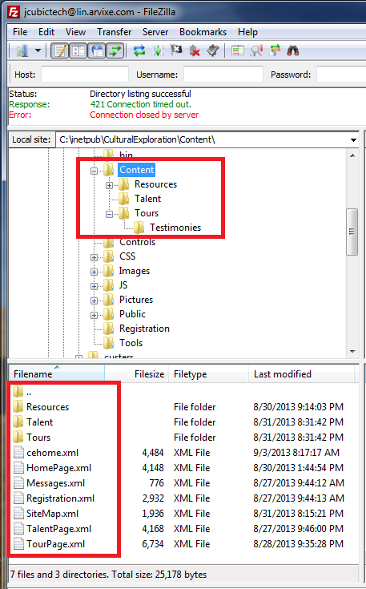

1. **Album** folder

This folder hosts the entire site album content. Video clips are not recommended to put into this folder as they take up a lot of space. Note that this folder has the same subfolders structure as the content folder.

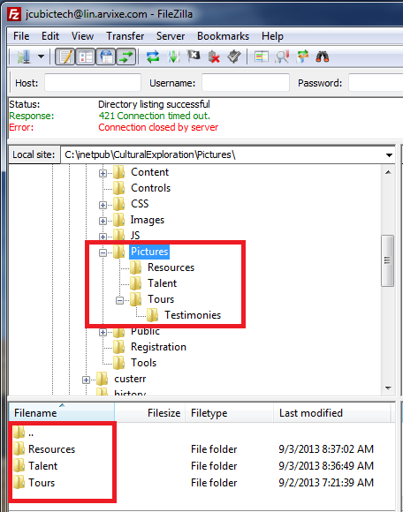

The *Album* folder can consists of many albums. Each album can be organized into *groups*. Each group is identified by a folder under an album. For example, the following screen shot show there are 3 *groups* for the album *Journey*:

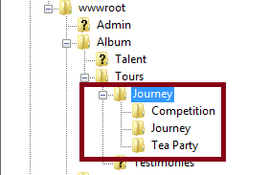

All the photos for each group are stored under the group’s folder.

1. **Documents** folder

This folder hosts the documents linkable from the CE site. The documents can be organized in the same way as other folders. A sample screen shot for the documents folder is shown below.

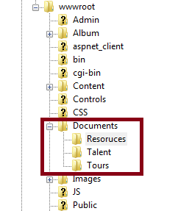

Note that all the documents stored in this folder are truly *public*, meaning that they can all be retrieved from anywhere in the internet. Therefore it is not a place to keep internal documents in this folder. Internal documents should be stored under the *Data* folder as shown belowas they are outside of CE website root folder and therefore is not accessible from the internet.

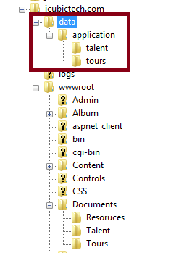

1. **Journey** folder

All tour journey reported back from teaches who take part in the cultural exchange tours are stored under the */content/ourney* folder. This folder is organized by teacher’s name. The sample screen shot shown below depicts the following structure:

* The teacher’s name is the journey subfolder name with no space between first and last name.
* There are 5 teachers’ journey reports.
* All photos taken for a teacher’s journey is stored under the subfolder *photos*.
* The journey content file, *SiriHulbert.xml*, is stored under the teacher’s journey subfolder. Note that the filename has the same name as the subfolder name.

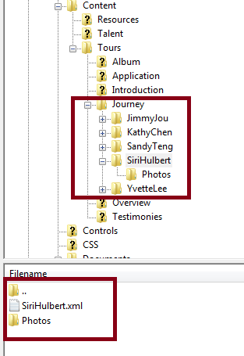

1. **Public** folder (Page folder)

This folder hosts the entire site’s web pages. Note that this folder has the same subfolders structure as the content and picture folder. Each content xml file has a corresponding page file, which can be generated by the tool *Create Page* under the *Admin* menu.

